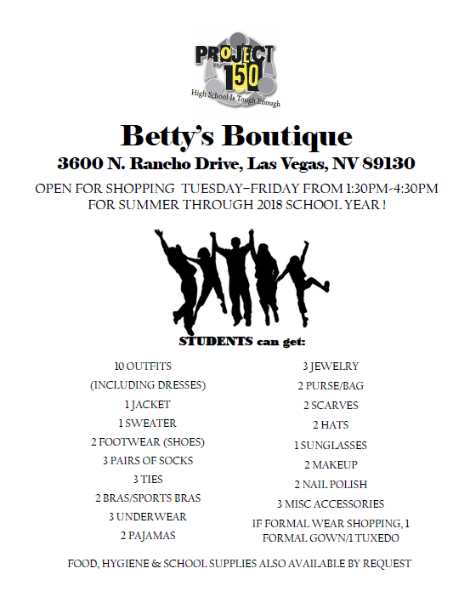
(702) 721-7150
If going to location bring school I.D
Or can order clothes from school social worker.

